导师简介
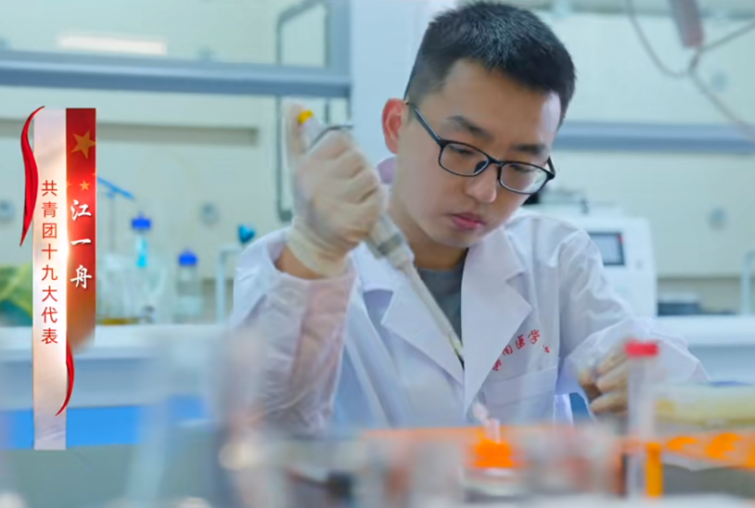
- 个人信息：
江一舟，男，博士，副研究员，硕士生导师。2017年本科毕业于南方科技大学生物科学专业，2022年博士毕业于澳门大学生物医药专业。2022年9月-12月于北京大学从事科研工作；2022年12月至今就职于海南医科大学衰老与肿瘤国际研究中心，从事衰老生物学研究。系中国共产主义青年团第十九次全国代表大会代表、海南省E类高层次人才、海南省人才团队成员、海南医科大学拔尖人才。现任中国民族医药学会方药量效研究分会常务理事、海南省青年科技工作者协会会员。
- 研究方向：
- 衰老的生物学机制
- 抗衰老干预方法的开发
- 衰老相关疾病的机制和治疗
- 学术及社会任职：
- 中国共产主义青年团第十九次全国代表大会代表
- 中国民族医药学会方药量效研究分会常务理事
- 海南省青年科技工作者协会会员
- 学术成果：
期刊论文
1. Jiang Y, Gaur U, Cao Z, Hou S & Zheng W. Dopamine D1- and D2-like receptors oppositely regulate lifespan via a dietary restriction mechanism in Caenorhabditis elegans. BMC Biology 20, 71 (2022).
2. Jiang Y*, Rubin L*, Zhou Z, Zhang H, Su Q, Hou S, Lazarovici P & Zheng W. Pharmacological therapies and drug development targeting SARS-CoV-2 infection. Cytokine & Growth Factor Reviews (2022).
3. Jiang Y*, Rubin L*, Peng T, Liu L, Xing X, Lazarovici P & Zheng W. Cytokine storm in COVID-19: from viral infection to immune responses, diagnosis and therapy. International Journal of Biological Sciences 18, 459-472 (2022).
4. Jiang Y, Gaur U, Cao Z, Hou S & Zheng W. Quetiapine shortens the lifespan of Caenorhabditis elegans through DOP-2, DAF-2 and RSKS-1. International Journal of Molecular Sciences 23(21), 12927 (2022).
5. Jiang Y*, Yan F*, Feng Z, Lazarovici P & Zheng W. Signaling Network of Forkhead Family of Transcription Factors (FOXO) in Dietary Restriction. Cells 9 (2020).
6. Jiang Y*, Peng T*, Gaur U, Silva M, Little P, Chen Z, Qiu W, Zhang Y & Zheng W. Role of Corticotropin Releasing Factor in the Neuroimmune Mechanisms of Depression: Examination of Current Pharmaceutical and Herbal Therapies. Frontiers in Cellular Neuroscience 13, 290 (2019).
7. Peng T*, Jiang Y*, Farhan M, Lazarovici P, Chen L & Zheng W. Anti-inflammatory Effects of Traditional Chinese Medicines on Preclinical in vivo Models of Brain Ischemia-Reperfusion-Injury: Prospects for Neuroprotective Drug Discovery and Therapy. Frontiers in Pharmacology 10, 204 (2019).
8. Li S, Jiang Y, Xing X, Lin R, Li Q, Zhou W, Qiu W & Zheng W. Protective Mechanism of Berberine on Human Retinal Pigment Epithelial Cells against Apoptosis Induced by Hydrogen Peroxide via the Stimulation of Autophagy. Oxidative Medicine and Cellular Longevity 2021 (2021).
9. Zhao X*, Liu L*, Jiang Y, Silva M, Zhen X & Zheng W. Protective Effect of Metformin against Hydrogen Peroxide-Induced Oxidative Damage in Human Retinal Pigment Epithelial (RPE) Cells by Enhancing Autophagy through Activation of AMPK Pathway. Oxidative Medicine and Cellular Longevity 2020, 2524174 (2020).
10. Zhao X, Huang X, Yang C, Jiang Y, Zhou W & Zheng W. Artemisinin attenuates amyloid-induced brain inflammation and memory impairments by modulating TLR4/NF-κB signaling. International Journal of Molecular Sciences 23, 6354 (2022).
11. Yan F, Wang R, Li S, Zhao X, Jiang Y, Liu L, Fang J, Zhen X, Lazarovici P & Zheng W. FoxO3a suppresses neuropeptide W expression in neuronal cells and in rat hypothalamus and its implication in hypothalamic-pituitary-adrenal (HPA) axis. International Journal of Biological Sciences 16, 2775-2787 (2020).
12. Yan F, Liao R, Silva M, Li S, Jiang Y, Peng T, Lazarovici P & Zheng W. Pristimerin-induced uveal melanoma cell death via inhibiting PI3K/Akt/FoxO3a signalling pathway. Journal of Cellular and Molecular Medicine 24, 6208-6219 (2020).
13. Cui Y, Wang K, Jiang D, Jiang Y, Shi D, DeGregori J, Waxman S & Ren R. Promoting longevity with less cancer: the 2022 International Conference on Aging and Cancer. Aging and Cancer 4:111–120 (2023).
（* 共同第一作者）
专著章节
1. Jiang Y & Zheng W. Cell Damage and Transformation in Aging. In: Gu D., Dupre M. (eds) Encyclopedia of Gerontology and Population Aging. Springer, Cham (2019).
- 联系方式： jiangyizhou@muhn.edu.cn

